**Use TextModules in smart forms**

1) Go to tcode smartforms. Choose the styles Radio button. Give a name starting with Z/Y. Click on Create

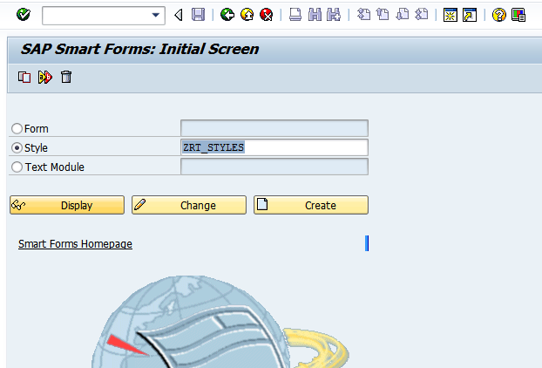

3) Click on Paragraph Format .Click on create

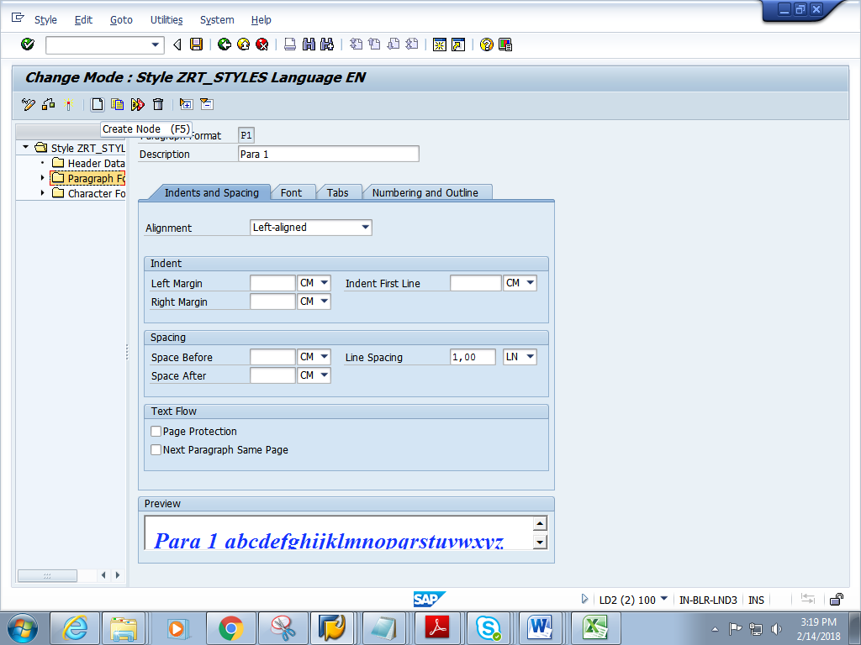

4) Give name as P1 and click the continue button

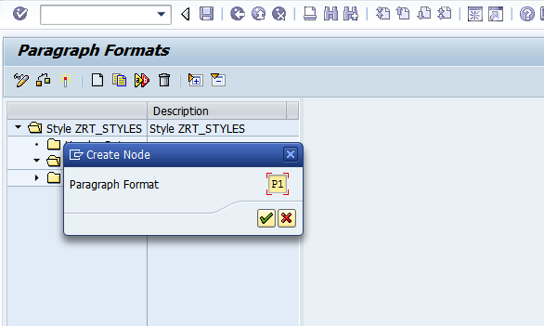

5) Give suitable font size, colour, type etc.

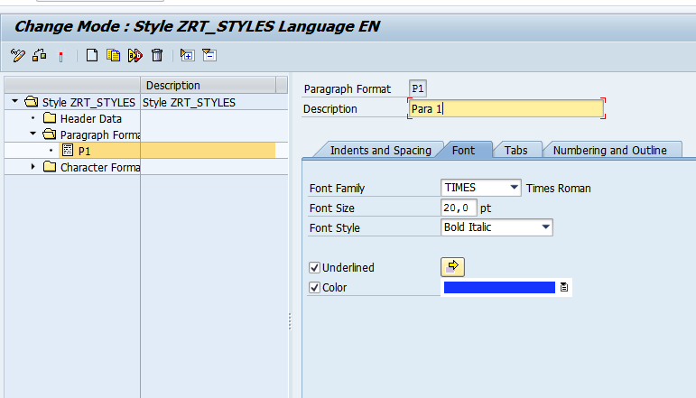

6) Click on Character Format. Click on create button

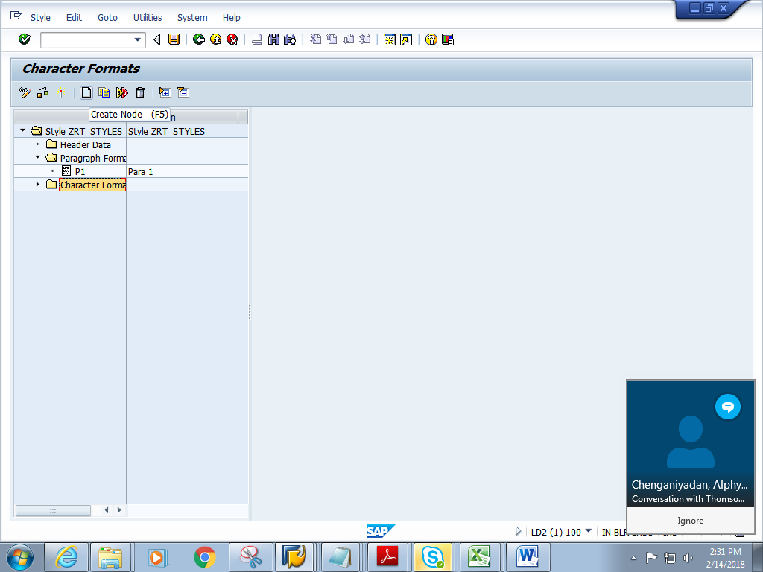

7) Give name as C1 and click on continue button

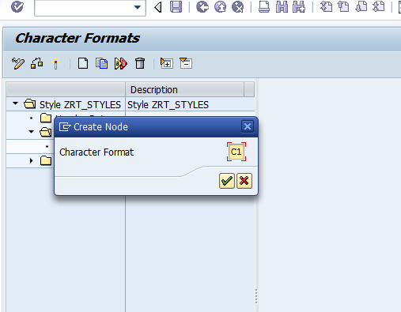

8) Give a suitable font size, colour, and type

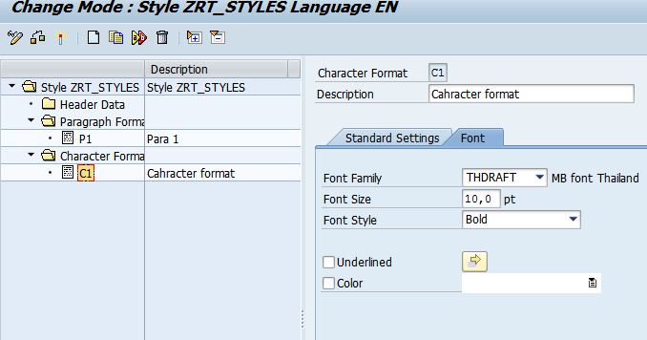

9) Click on Header data and give the paragraph format as P1.

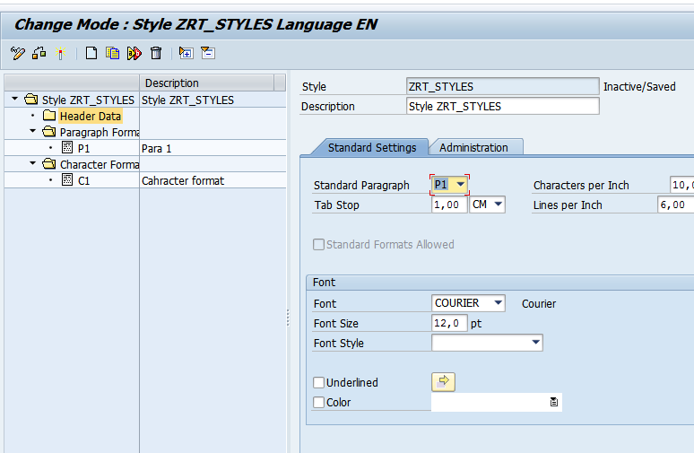

10) Save and activate the style.

11) Open any smartform created earlier. Give the name of smart style.

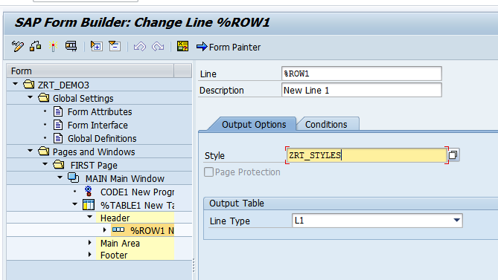

12)Save and activate the form

13) Click on Print preview

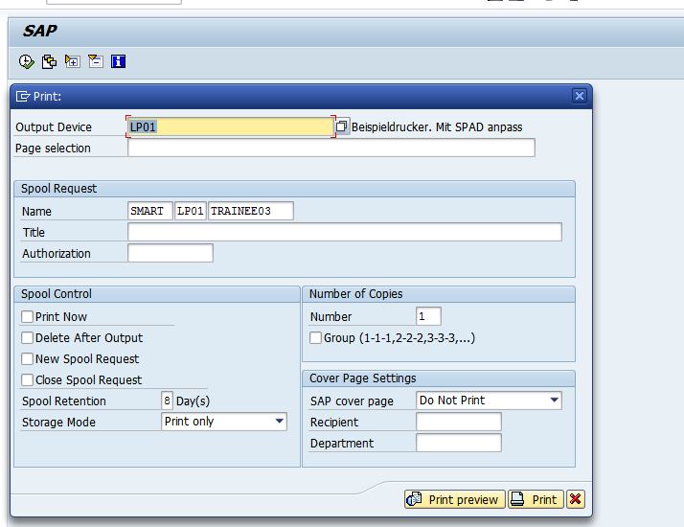

14) Expected output is as follows.

